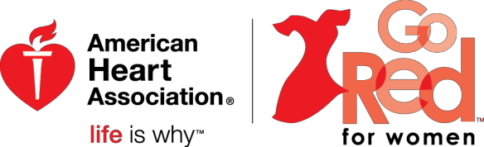

What is Go Red for Women?

Go Red for Women is the American Heart Association’s national campaign to increase awareness of heart disease — the leading cause of death for women — and to inspire women to take charge of their heart health. The grassroots campaign has since grown into a vibrant national movement as more women, men,
celebrities, healthcare professionals and politicians embrace and elevate the cause of women and heart disease. The yearlong campaign kicked off at the annual Go Red for Women Luncheon provides women of all generations with tips and information on healthy eating, exercise and risk factor reduction, such as smoking cessation, weight maintenance, blood pressure control and blood cholesterol management.

Go Red for Women has four components:
♥ Raising funds for women’s awareness, education and research programs
♥ Public education to increase awareness that heart disease is the No. 1 killer of women
♥ Educating healthcare professionals to assure that providers treat women according to guidelines
♥ Educating lawmakers about this issue

What is Circle of Red?
♥ An elite group of women (and men) who have the influence and resources to significantly impact the community by providing a personal commitment to help find a cure for the number one killer of women.

Who is a Circle of Red Member?
♥ An individual who can provide a personal commitment of $1,000

What benefits my participation as a Circle of Red Member?
♥ Help fund research grants needed to find a cure for Longview’s number one killer of women
♥ Increase continuing medical education programs to help physicians incorporate the AHA’s guidelines for preventing heart disease among women
♥ Increase AHA’s CPR in school programs, where an estimated 200,000 kids have been trained and many lives have been saved.
♥ Increase the awareness and prevention of heart disease in women
♥ One in 3 women die of heart disease, stroke and other cardiovascular diseases.”

Recognition as a Circle of Red Member
- Tickets to Go Red for Womens Luncheon
- Special Verbal recognition during the 2016 GRFW luncheon
  - Complimentary professional photo taken for COR events
- Special recognition on ALL Go Red for Women sponsor signage and marketing materials
(invitations, media, billboards if group desires)
  - No membership meetings
- Option to donate purse for the “Purse-onality auction at the GRFW luncheon
  - Invitation to two social Circle of Red events throughout the year
1 All funds are non-restricted

